Unity Tutorial: Dialogue System

1. Setting up the UI

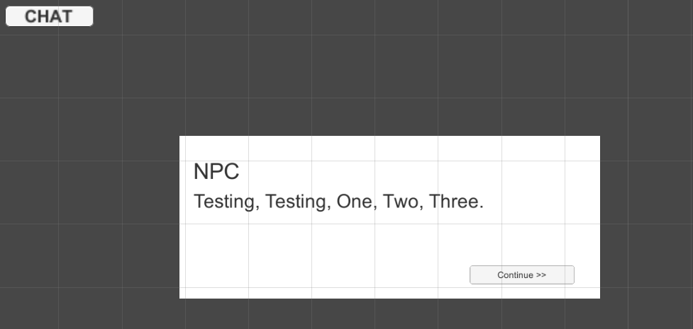Before making dialogue, it set up the UI panel and lay it out similar to the scene and it must have a couple of text and two separate buttons.

1. Making the scripts

Create an empty object and labelled DialogueManager and create a new C# script with the same name for it. Add the code below and then go back to Unity and create a new script in order the sentences to go through the manager and create newer sentences and host the class as its own.

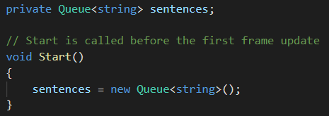[Code for DialogueManager]

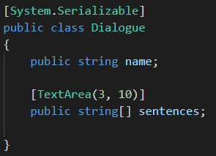[Code for Dialogue]

Then create a 3rd script labelled TriggerDialogue place it on the TestButton and add the code below in the script and it should display sentences tab and can add many elements as possible and write a brief dialogue. And finally add On Click() with Testbutton and link it with TriggerDialogue().

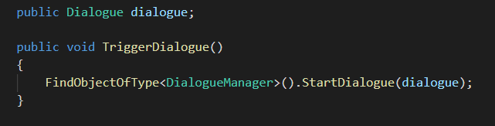[Code for TirggerDialogue]

1. Making the dialogue activate

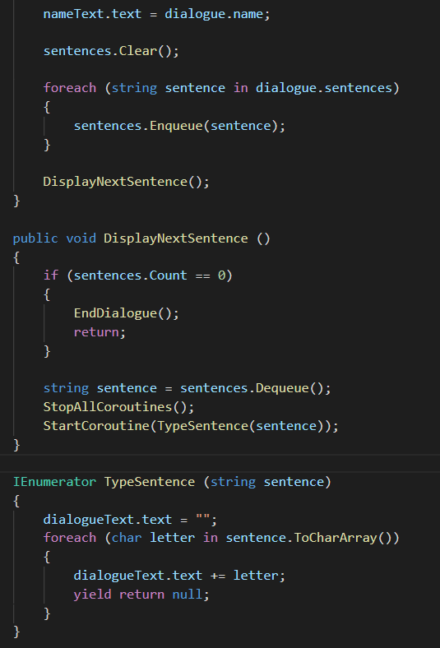Make a public void StartDialogue (Dialogue dialogue) {} in DialougeManager and include the code below in it and it will activate when pressing continue button.

Once it typed, go to ContinueButton for On Click() add the DialogueManager and for function click on DisplayNextSentence().

To make the continue button work properly so the build will recognise the UI in the scene. Then add both name text and dialogue text in the DialougeManager and now it should work.

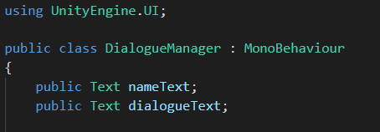

1. Animating the dialogue box

In order to animated, go to Animator in Unity, create two different anim file one for open and for close. For open record the frame as normal. As for close make the box underneath the camera frame. Go to animator set DialogueClose as layer default state and in the parameters tab and select bool labelled as IsOpen and create a transition to for both DialogueBox open and close and turn off loop and HasExitTime. Add a condition to true and opposite for false.

In the DialougeManager script add public Animator animator; in above page and at the bottom add

void EndDialogue() {animator.SetBool("IsOpen", false);}

After it is in add the animator in the DialougeManager object and now it should be functional.